5th IEA PVPS TCP’s UTILITY WORKSHOP
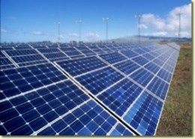
Peer2Peer Electricity Trade
Preparation Paper

For an optimal preparation of the Video Conference on 20 April 2020, 9.30-11.30 hours (CET) and 13.00-15.00 hours (CET), and in order to be as effective as possible in 2+2 hours, we would appreciate it if you could fill out this form, which will be the basis of a general information sheet, which will be sent to all registered participants prior the workshop.
Please send it back to h.fechner@tppv.at not later than 12 April 2020, in order for us to prepare a sound background information for the workshop.

Name:
Affiliation: | Country:
Please fill in A) OR B)
- In case you are working for a P2P platform/company, please introduce this platform shortly:
- Name of P2P platform:
- Short description of this P2P activity:

Website:

- In case you are not working for a P2P platform/company, please provide some words about your motivation to participate in this workshop, Background, experiences with P2P, etc.

Please tell us your expectations for the Workshop

If you have specific recommendations for topics to be addressed, please mention here

